許智能 Sodio Chih-Neng Hsu  Professor  Bioinorganic & Inorganic Chemistry  Department of Medicinal and Applied Chemistry, Kaohsiung Medical University, Kaohsiung 807, TAIWAN  Office: (886) 7-3121101 Ext. 6984 Fax: (886) 7-3125339  Email: sodiohsu@kmu.edu.tw | 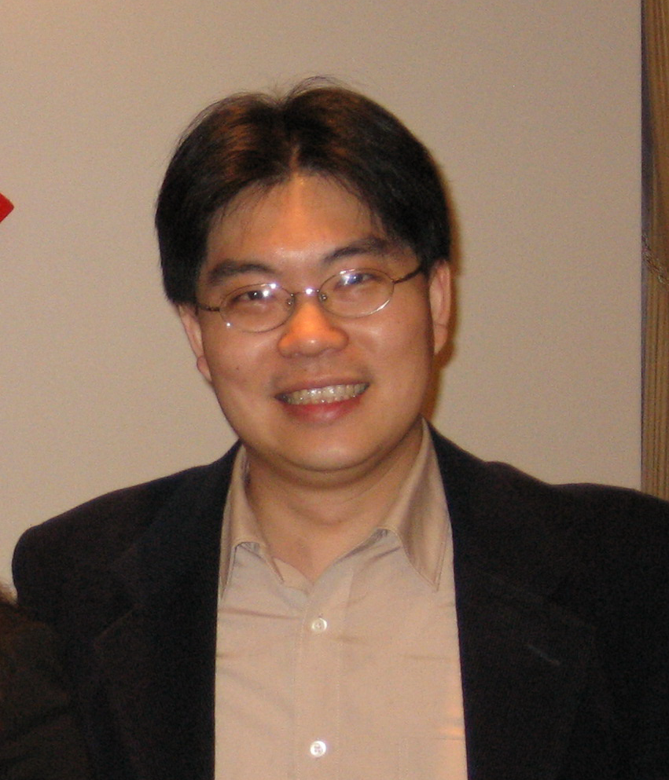
Research interests:
Structural and functional bio-minic metalloprotein active sites
Supramolecular chemistry and their molecular recognition
Organometallics of transition metal carbonyl, phosphine, or alkyne complexes
Selected Publications
- Chen, Y.-H.; Lin, T. T. Y.; Chen, H.-Y.; Kao, C.-L.; Chen, H.-Y.; Hsu, S. C. N.*; Carey, J. R.; Chiang, M. Y. “A simple competition assay to probe pentacopper(I)-thiolato cluster ligand exchange” J. Inorg. Biochem. 2013, 120, 24-31.
- Hsu, S. C. N.*; Chang, Y.-L.; Chuang, W.-J.; Chen, H.-Y.; Lin, I. J.; Chiang, M. Y.; Kao, C.-L.; Chen, H.-Y. “Copper(I) Nitro Complex with an Anionic [HB(3,5-Me2Pz)3]− Ligand: A Synthetic Model for the Copper Nitrite Reductase Active Site” Inorg. Chem. 2012, 51, 9297-9308.
- Su, C.-J.; Tang, Y.-H.; Yu, F.-L.; Wu, R.-R.; Hsu, S. C. N.*; Kao, C.-L.*; Huang, H.-Y.; Chen, P.-Y.* “Extraction of Cupric Ions with Ionic Liquids Containing Polypyridine-type Small Molecules or Peripherally Pyridine-modified Dendrimers” Chemistry – An Asian Journal 2012, 7, 2438-2445.
- Lin, P.-C.; Chen, H.-Y.; Chen, P.-Y.; Chiang, M.-H.; Chiang, M. Y.; Kuo, T.-S.; Hsu, S. C. N.* “Self-Assembly and Redox Modulation of the Cavity Size of an Unusual Rectangular Iron Thiolate Aryldiisocyanide Metallocyclophane”Inorg. Chem. 2011, 50, 10825-10834.
- Hsu, S. C. N.*; Lin, T. T. Y.; Chen, H.-Y.; Chuo, S.-W.; Kao, C.-L.; Chen, P.-Y.; Hung, M.-Y. “Potassium-encapsulated arsenic-dithiolato compounds: Synthesis, structural calculation, and biological relevance”Kaohsiung J. Med. Sci. 2011, 27, 424-429.
- Chuang, W.-J.; Lin, I-J.; Chen, H. Y.; Chang, Y.-L.; Hsu, S. C. N.* “Characterization of A New Copper(I)-ntirito Complex That Evolves Nitric Oxide” Inorg. Chem. 2010, 49, 5377-5384.
Chelation or Dimerization on the Asymmetrical N-aryl-N’-alkylpyridyl ß-Diketiminato Metal Complexes

Sodio C. N. Hsu
Department of Medicinal and Applied Chemistry, Kaohsiung Medical University, Kaohsiung 807, TAIWAN
sodiohsu@kmu.edu.tw

A series of asymmetrical N-aryl-N’-alkyl β-diketiminate bearing a pendant pyridyl group (L₁H –L₄H) were synthesized in two-step reaction from acetylacetone and corresponding appropriate amines. Deprotonation of the asymmetrical N-aryl-N’-alkylpyridyl β-diketiminate by CuO^{t}Bu to give their corresponding copper(I) complexes stabilized by the N-aryl-N’-alkylpyridyl β-diketiminato ligand. All copper(I) complexes were characterized by NMR spectroscopy and single crystal X-ray diffractometry to confirm their structures and ligand binding modes. The observed binding mode differences are rationalized by considering the steric inference of N-aryl substituent and the length of pyridyl arm of N-aryl-N’-alkyl β-diketiminate ligand.

